Walker Specialties, Inc.

Roller Shade GUIDE

**WALKER SPECIALTIES, INC.**

**50 Messina Drive**

**Braintree, MA 02184**

**617-333-3220 617-361-3302*f***

**info@walkerspecialties.com**

[**www.walkerspecialties.com**](http://www.walkerspecialties.com)



**Offering a comprehensive range of stylish and functional window coverings to enhance any space, Walker Specialties, Inc. is a trusted provider of premium window treatment solutions, catering to residential, commercial, and hospitality projects.**

**Manual Clutch Roller Shades**

* Economical and efficient choice for both residential & commercial projects
* Customizable- can be cut to any nearly any size with many finishing options of fascia, casette and more!
* Independent control of privacy and light in any space
* Durable & high quality chain operated clutch system by Rollease Acmeada™.
* Safety In Mind -- Chain covers and hold downs provided.

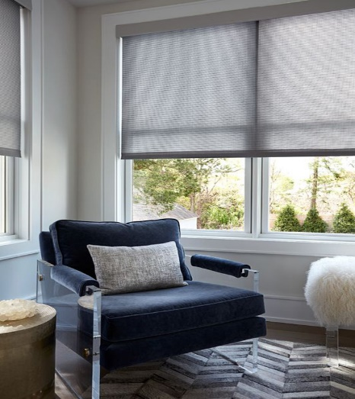 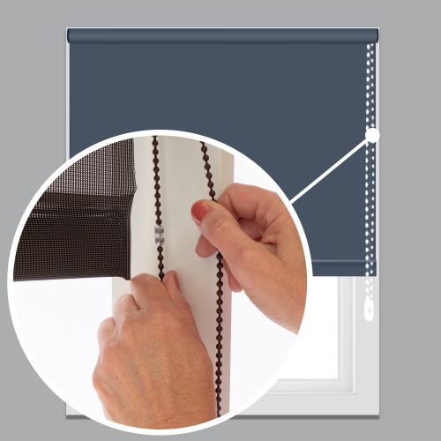

**Motorized Roller Shades**

* Two windows with shades on them

  Description automatically generatedPopular option for residential & commercial projects
* Comfort & convenience- customizable preset schedules for your shades elegantly enhances energy efficiency, privacy and ambiance.
* Custom graphics available
* Quiet operation.
* Battery, DC or AC powered; UL listed motors.
* Fully integrateable into automation and AV systems or control with remote, switch, or mobile app.
* Ideal for those who find it difficult to operate a manual clutch shade due to window location, obstruction or disability.
* Reduced wear and tear make motor shades a long lasting product.
* Safety in Mind -- Cordless operation

**Spring Roller Shades**

* Most cost effective option for residential spaces.
* Independent control of privacy and light in any space
* Highly customizable -- cut to size, many finishing & mounting bracket options available
* Multiple roller types to choose from: convolute, wood, aluminum & steel
* Safety in mind -- cordless operation

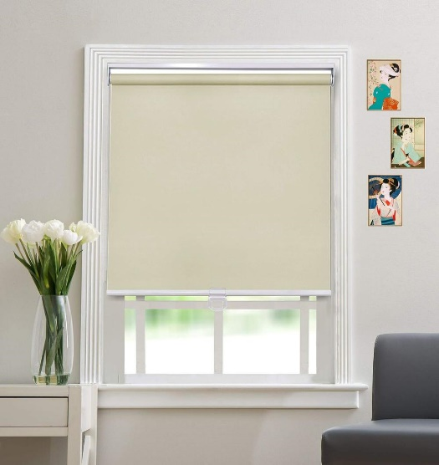

**Fabrics**

Whether your project calls for a sheer light filtering fabric or complete black out shades, we can accommodate your needs. Walker Specialties, Inc. offers a complete range of high fabric choices from Rollease Texstyle, Mermet, Phifer, Butler, Indiana Coating and more. These high quality textiles are lab and field tested and are often PVC-Free, Flame Retardant, antibacterial, Green Guard Certified, and Energy Efficient.

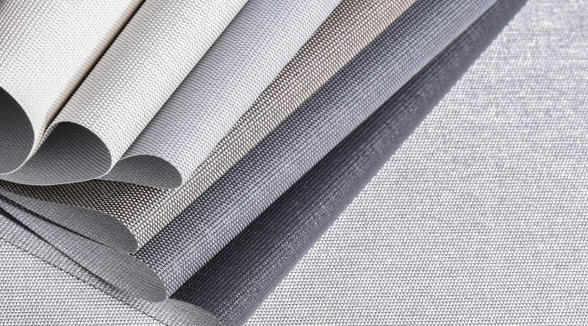

**Additional Products and Hardware:**

* Decorative and Utility Drapery Hardware
* Bead Chain & Bead Chain Tools
* Replacement Parts

**OUR PARTNERS:**

**Specifications, drawings and product information available upon request.**

**WALKER SPECIALTIES, INC.**

**50 Messina Drive**

**Braintree, MA 02184**

**617-333-3220 617-361-3302*f***

**info@walkerspecialties.com**

**www.walkerspecialties.com**