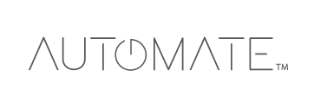

- Motor Options:
-Lithium Ion
-Conventional Battery: charged via outlet or solar power
-12V DC: low voltage, plug-in
-120V AC: plug in or hardwired

- Control Options:
-Mobile App
-Remote: 1 and 15 channels
-Wall Switch: 5 channels, simple wall surface installation
-Rooted Wall Switch: 1, 2 and 5 channels, Requires cutting into drywall.

- Ideal for both Residential and Commercial projects:
-Simple installation & operation
-Intergratable into existing automation systems
-Customizable limits and settings
-Retrofit brackets with Skyline and R-Series systems
-Multiple finishing options of Fascia and Cassette