**ROLLER SHADE MEASUREMENT GUIDE**

Tools Required:

-**Steel** Tape Measure

**STYLES OF MOUNTING**

**INSIDE MOUNT: OUTSIDE & CEILING MOUNTS**:

(Mounted inside window casing) (Mounted **on** window frame or **above** window)

Measurement Guide for Inside Mount: Measurement Guide for Outside & Ceiling Mount:

Molding

Casing

Windowsill

**Width:** Measure the top, center and bottom of the window casing. Deduct ¼” inch off the narrowest measurement. Record this as your final width.

**Height:** Measure from the top of the window to the top of the windowsill, or to where you want the fabric to hit when fully extended.

**Width:** Measure the entire area to be covered by shade. We recommend a minimum of 1” overlap on either side to provide adequate light blockage.

**Height:** Measure height to be covered from top of roller location to windowsill, or to where you want the fabric to hit when fully extended.

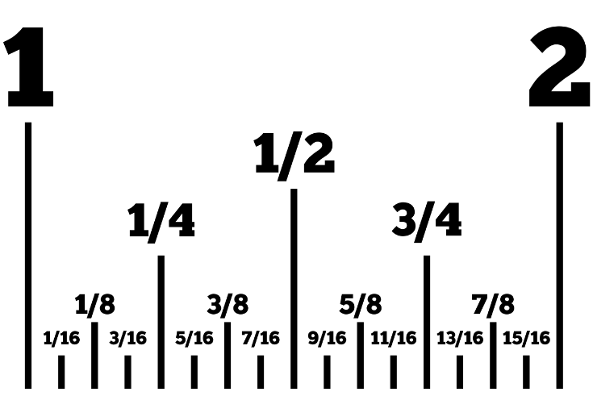

**TAPE MEASUREMENT GUIDE**

ROOM:_______________________________

* Inside Mount
* Outside Mount

Height: Width:

ROOM:_______________________________

* Inside Mount
* Outside Mount

Height: Width:

ROOM:_______________________________

* Inside Mount
* Outside Mount

Height: Width:

ROOM:_______________________________

* Inside Mount
* Outside Mount

Height: Width:

ROOM:_______________________________

* Inside Mount
* Outside Mount

Height: Width:

ROOM:_______________________________

* Inside Mount
* Outside Mount

Height: Width:

ROOM:_______________________________

* Inside Mount
* Outside Mount

Height: Width:

ROOM:_______________________________

* Inside Mount
* Outside Mount

Height: Width:

ROOM:_______________________________

* Inside Mount
* Outside Mount

Height: Width:

ROOM:_______________________________

* Inside Mount
* Outside Mount

Height: Width: